SELECT: | PRICE: | QUANTITY: | TOTAL COST:
METAL PINS | £2.50 |  | £
HANDMADE KNITTED POPPY | £2.00 |  | £
KNITTED COLLAR POPPY FOR DOGS | £2.00 |  | £
WRISTBANDS | £2.00 |  | £
CARSTICKERS | £2.00 |  | £
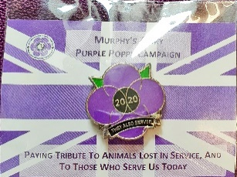
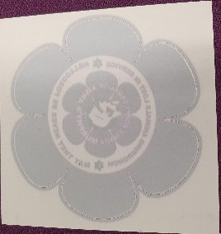
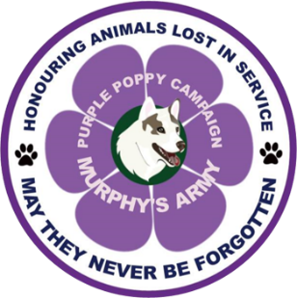
Murphy Army Poppy order form
Please return order forms to jenny.whitehouse@sandwell.ac.uk
Car stickers
Knitted collar poppy for dogs
NAME:
EMAIL:
LOCATION:
Are you happy for us to hand deliver to you?
Handmade knitted poppy
Wristbands
Metal pins
All proceeds will go to Murphy’s Army.
TOTAL AMOUNT:

