|  |  |  |  |
| --- | --- | --- | --- |
| **SELECT:** | **PRICE:** | **QUANTITY:** | **TOTAL COST:** |
| POPPY 1 | £2.50 |  | £ |
| POPPY 2 | £3.00 |  | £ |
| POPPY 3 | £3.00 |  | £ |
| POPPY 4 | £2.50 |  | £ |
| POPPY 5 | £3.00 |  | £ |
| POPPY 6 | £3.00 |  | £ |
| POPPY 7 | £3.00 |  | £ |
| POPPY 8 | £3.00 |  | £ |

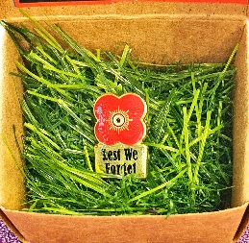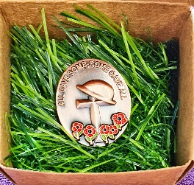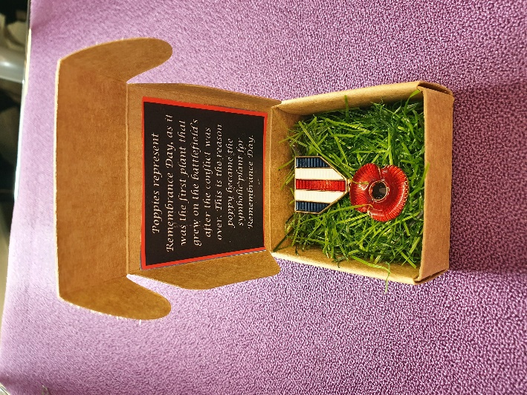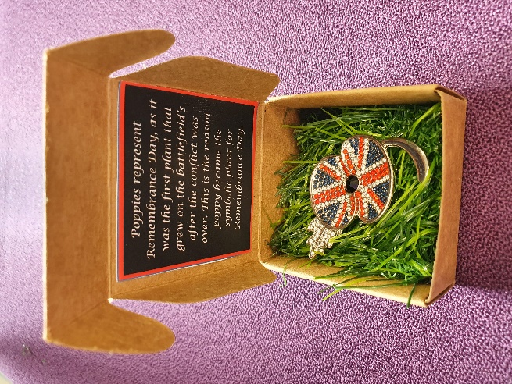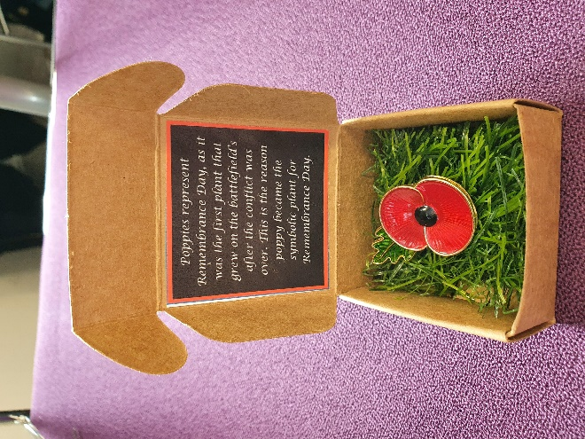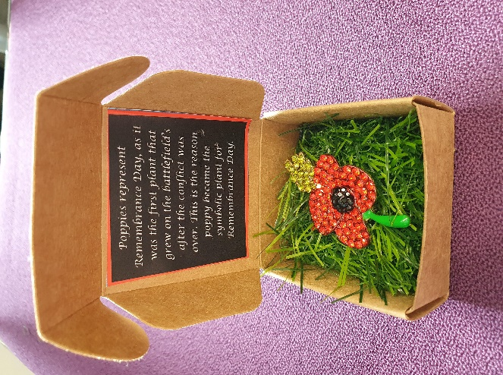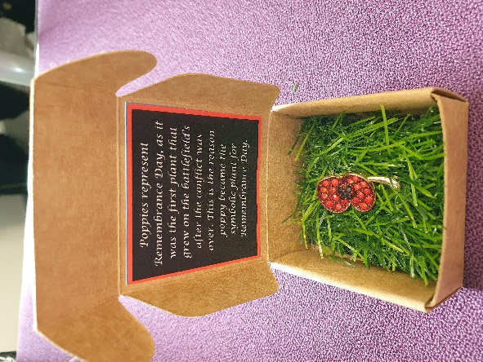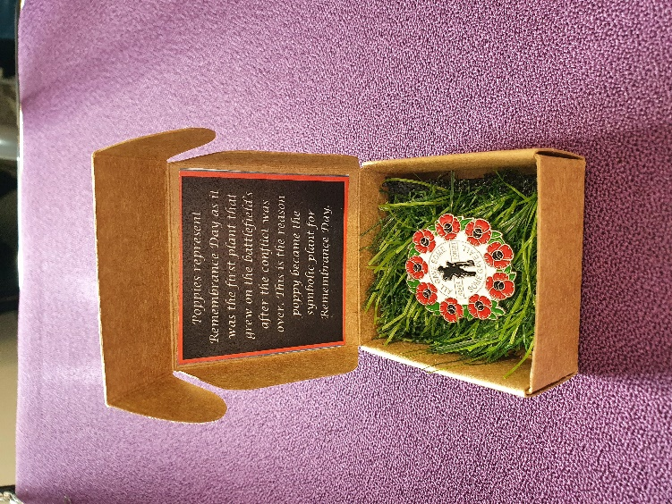

**All proceeds will go to The Royal British legion.**

**Poppy order form**

**NAME:**

**EMAIL:**

**LOCATION:**

**Are you happy for us to deliver to you? Yes/no**

Poppy 8

Poppy 7

Poppy 6

Poppy 5

Poppy 4

Poppy 3

Poppy 2

Poppy 1

**TOTAL AMOUNT:**