Photo | Price | Order amount | Paid | Full name and department | ID number
Item:
Pet memorial bench with mini bouquet of flowers and tea light candle
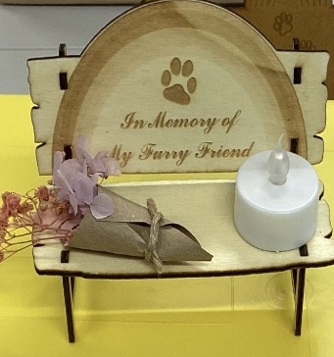 | £5
Item:
Pet memorial planter
 | £1.50
Item:
Bulldog figurines
 | £1
 | £1
 | £1
 | £1

