How to place your order with us:

**\*\*\* Online orders - please email your order form to the address below\*\*\***

**At our reception in 2F54**



**foundationscreations@sandwell.ac.uk**



**Post box outside 2f54 (follow the butterflies)**



|  |  |
| --- | --- |
| **Poppy number** | **Quantity** |
| 1  Knitted badge  £2.50 |  |
| 2  Dog collar/zip pulls  £4.00 |  |
| 3  Pin badge  £3.50 |  |
| 4  Knitted poppy for dogs  £2.50 |  |
| Total amount | £ |

**NAME:**

**EMAIL:**

**LOCATION:**

**Are you happy for us to hand deliver to you?**

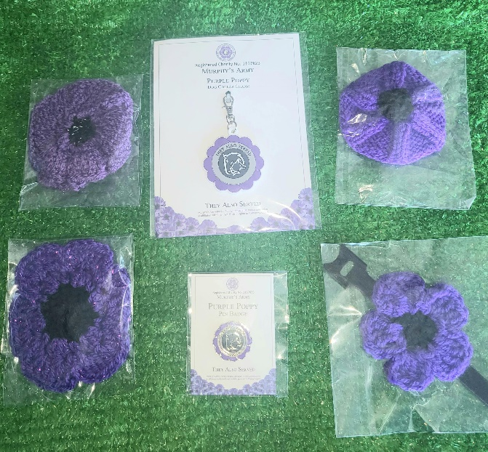

1

|  |  |  |  |
| --- | --- | --- | --- |
| Picker | Packed | Delivered/collected | Paid |
| Signed:  Date: | Signed:  Date: | Signed:  Date: | Signed:  Date: |



**All proceeds will go to Murphy’s Army**

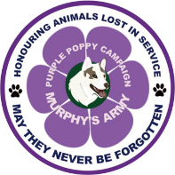

**Please follow us**



4

3

2

Company use only:

