How to place your order with us:
*** Online orders - please email your order form to the address below***



foundationscreations@sandwell.ac.uk
In our classroom in 2F54
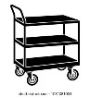

The travelling poppy trolley
Post box outside 2f54
Item number | Quantity
6
rubber bracelets
7
dog pin A
8
dog pin B
9
human knitted poppy badge
Total
amount (£)
Item number | Quantity
1 keyring
2
dog collar poppy
3
fabric sew on patch
4
2026 pin badge
5
pin badge
NAME:
EMAIL:
LOCATION:
Are you happy for us to hand deliver to you?
3
4
7
8

Picker | Packed | Delivered/collected | Paid
Signed:  Date: | Signed:  Date: | Signed:  Date: | Signed:  Date:

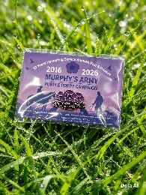
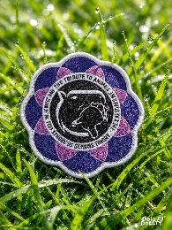
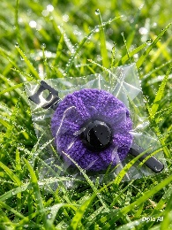
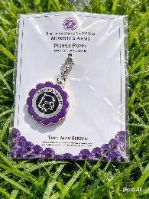
4
3
2
1


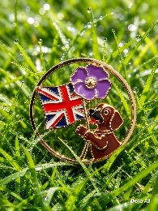

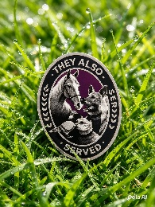
8
7
6
5

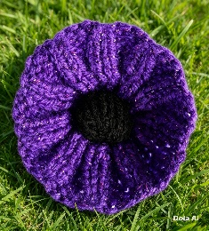
9

Prices
1 | £3.00 | 4 | £3.00 | 7 | £3.50
2 | £3.00 | 5 | £3.00 | 8 | £3.50
3 | £3.00 | 6 | £3.00 | 9 | £3.00




Proceeds will go to Murphy’s Army
Please follow us

